

**ENCS3330, DIGITAL INTEGRATED CIRCUITS.**

**Assignment #1**

**Student: Mohammad Salem – 1200651.**

**Section 2.**

**Dr: Khader Mohammad**

**Date: 11/12/2023.**

**1.CMOS Device (Inverter Gate)**

Inverter on schematic:

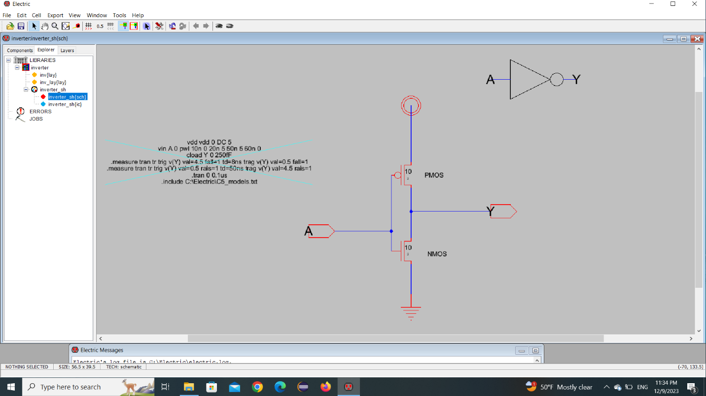

Inverter code:

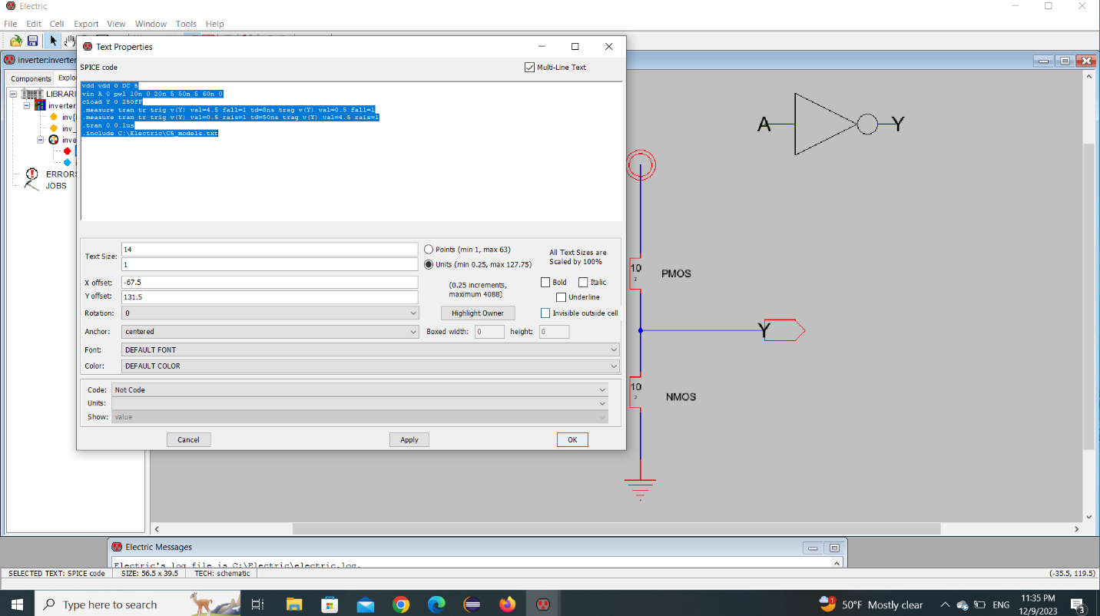

Inverter icon:

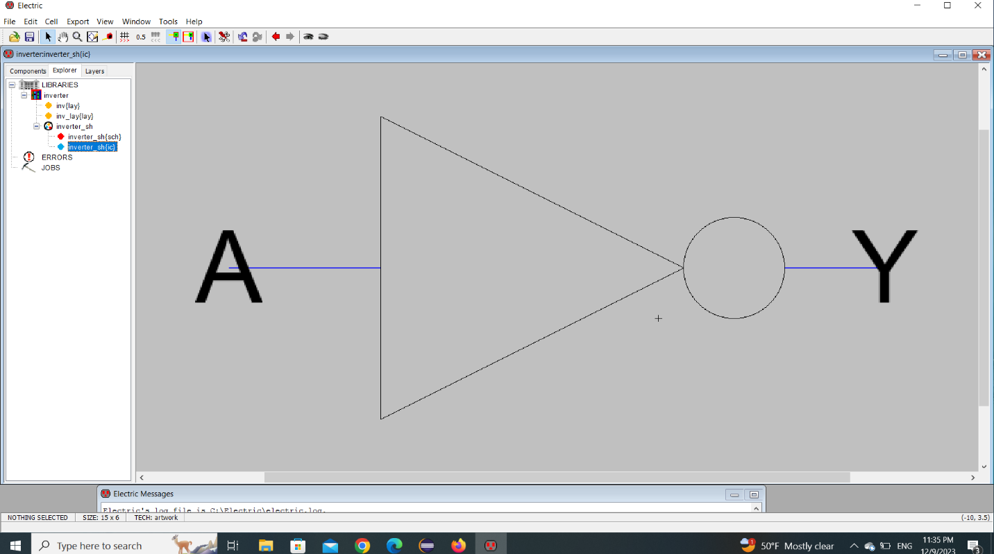

Inverter in layout

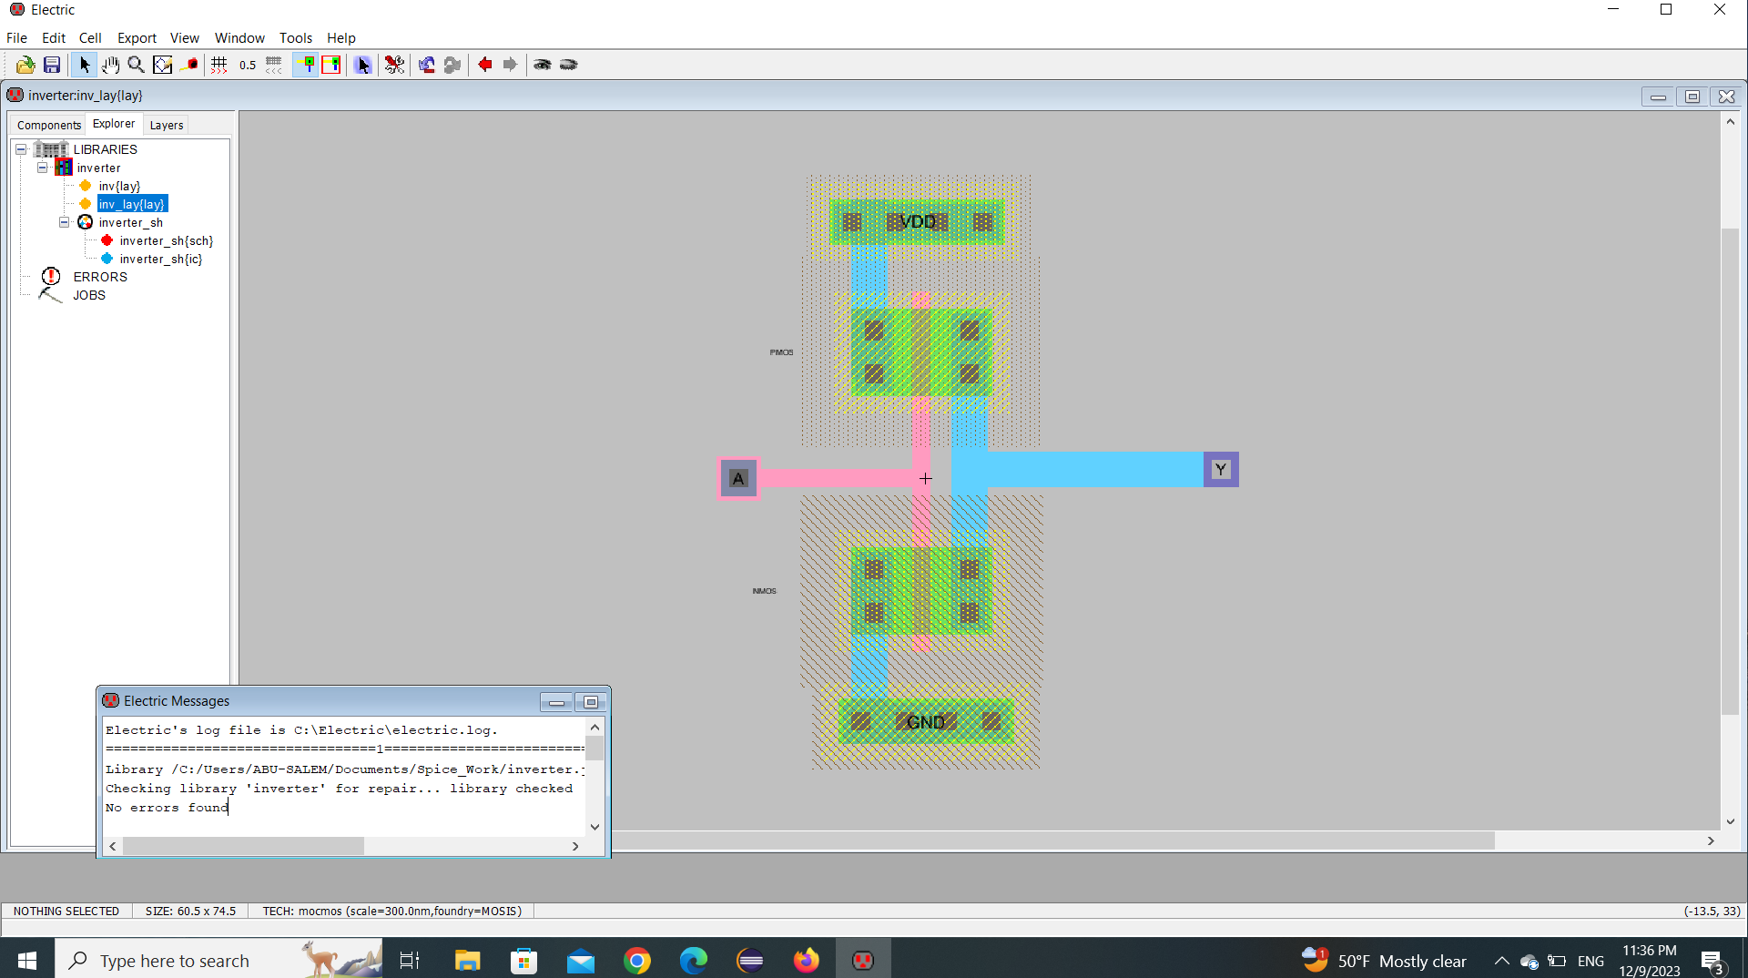

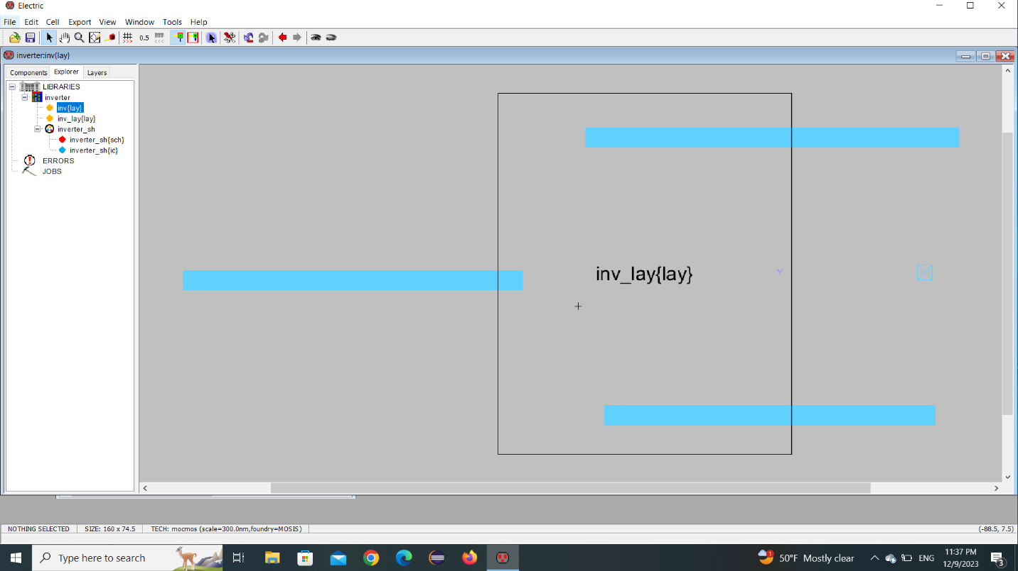

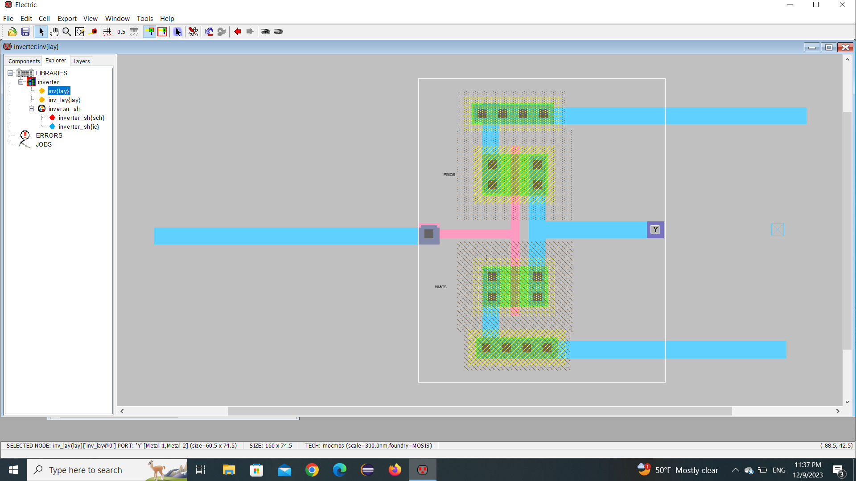

Elaborate results, and waveform:

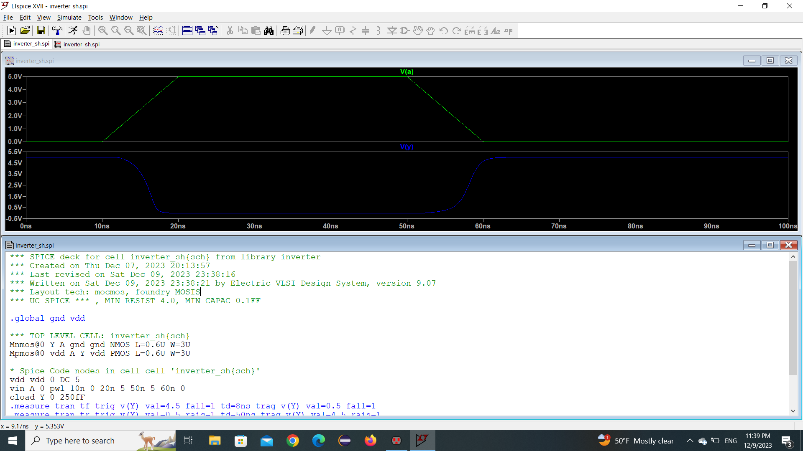

Final result with tr and tf :

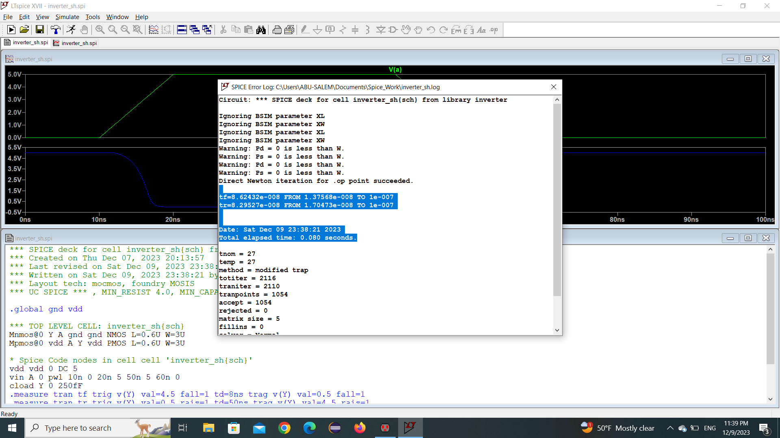

**2. three input NAND Gate**

Three input NAND gate on schematic:

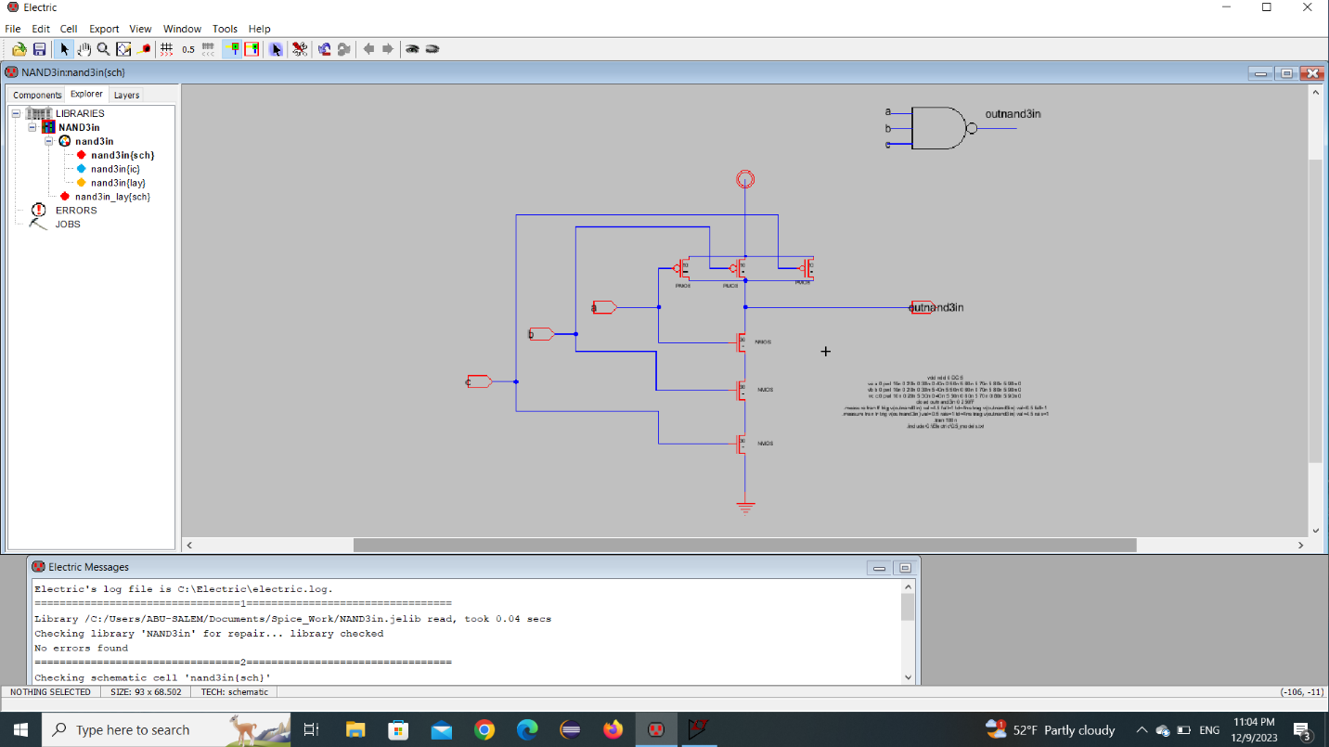

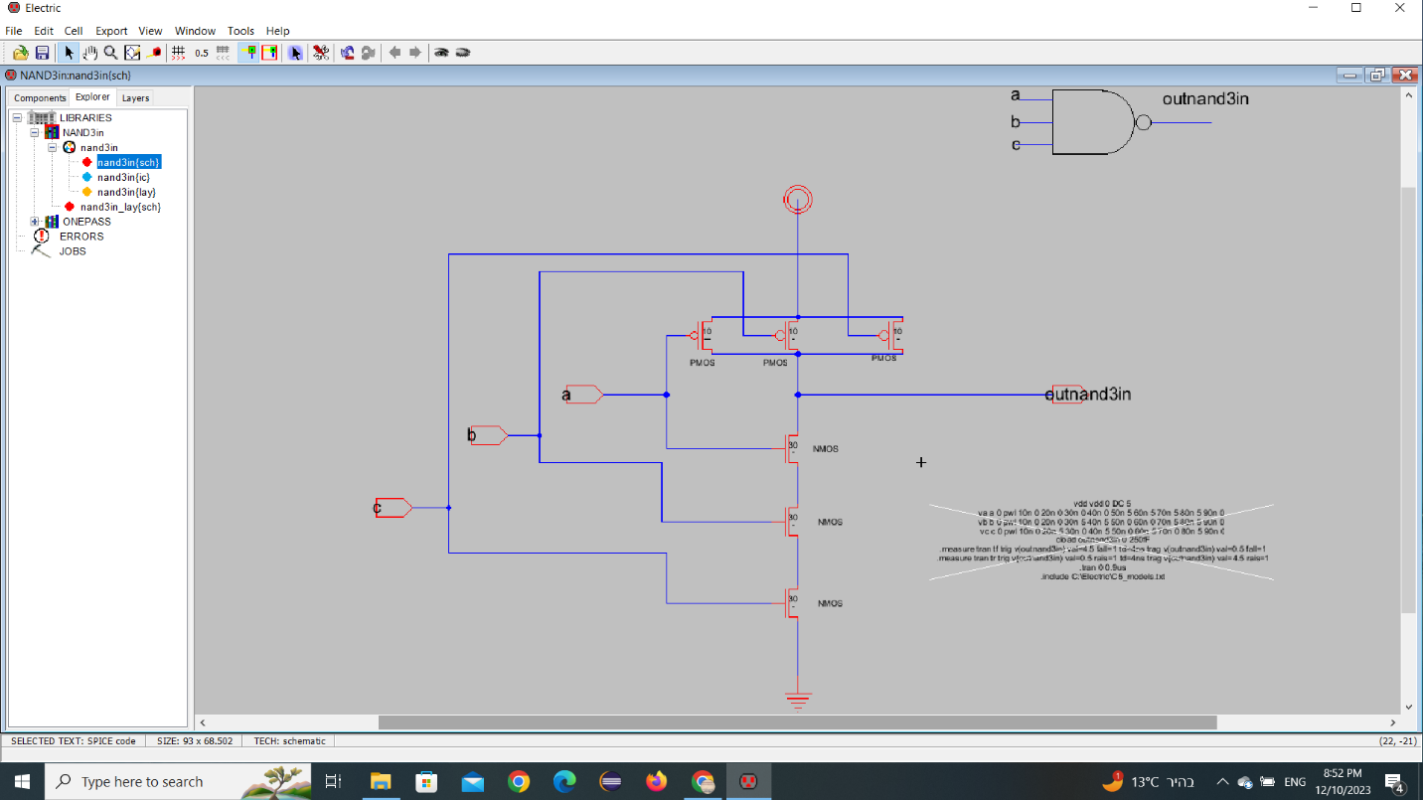

Nand icon:

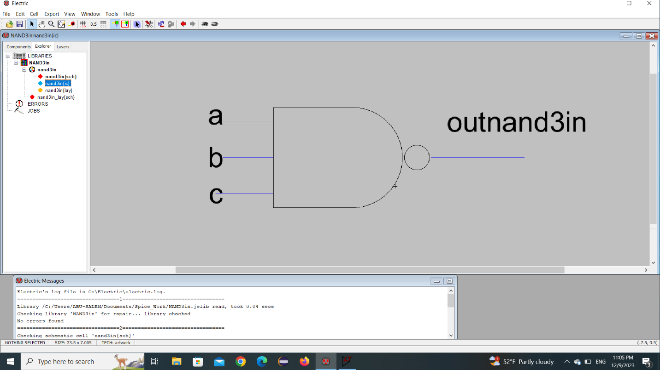

NAND Layout:

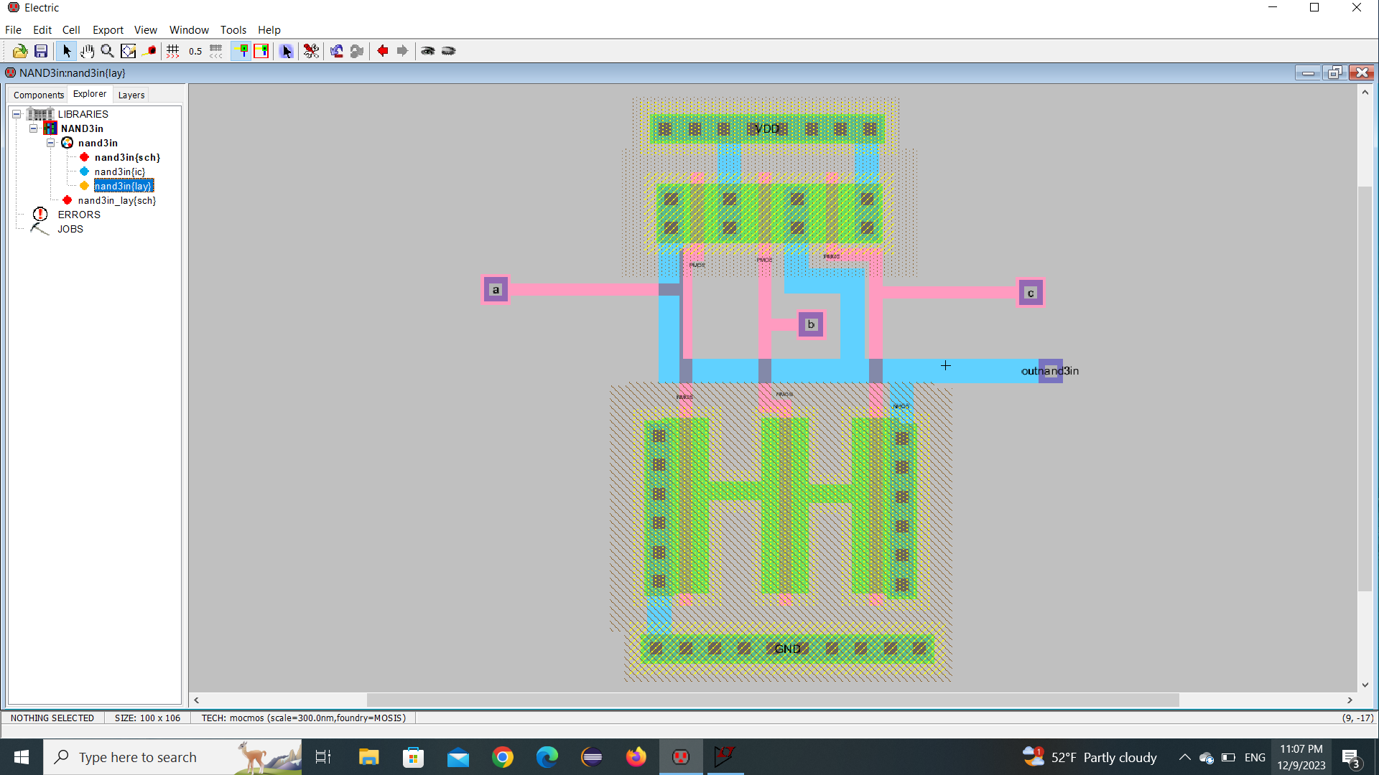

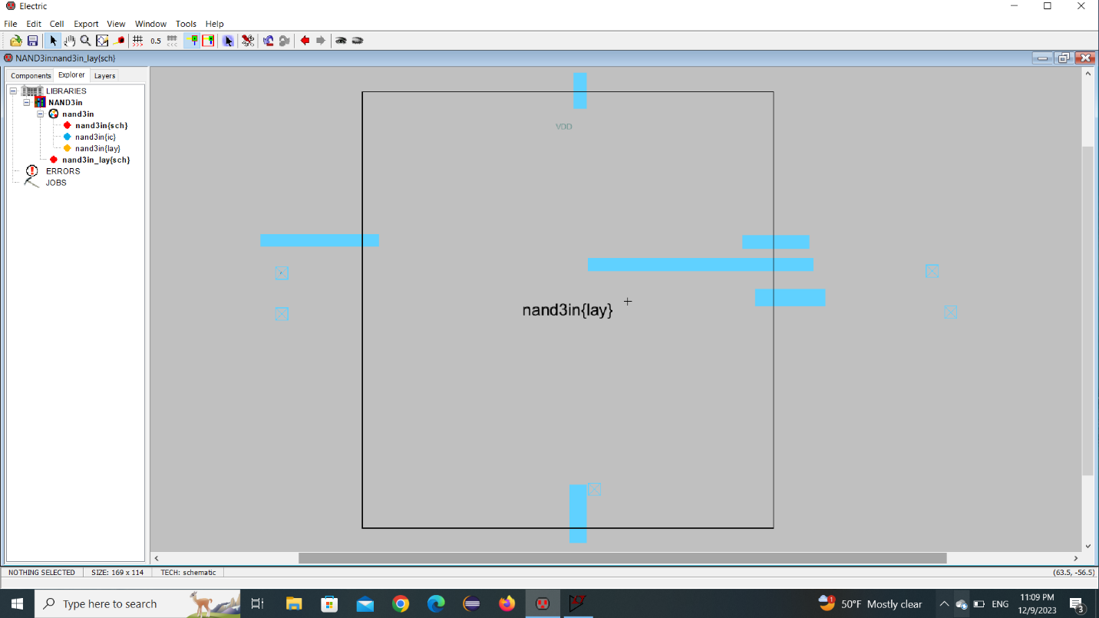

Final result with tr and tf :

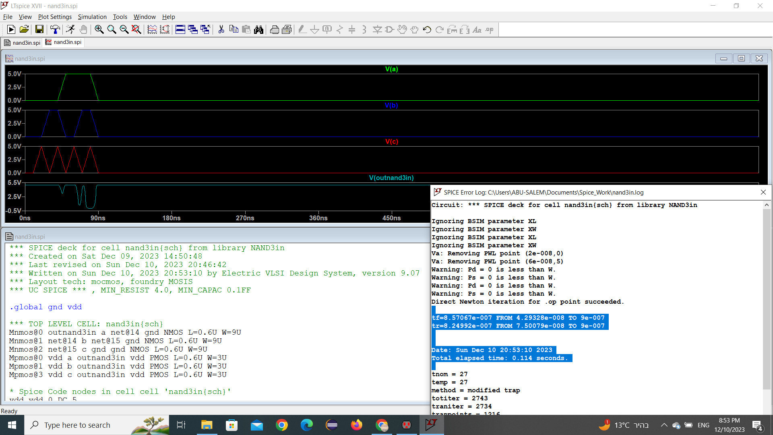

**3. three input NOR Gate**

Three input NOR gate in schematic

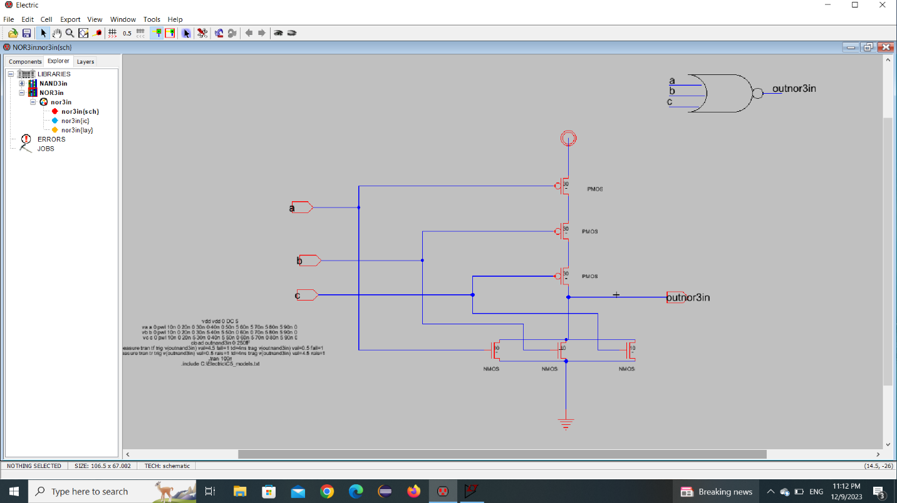

Nor icon:

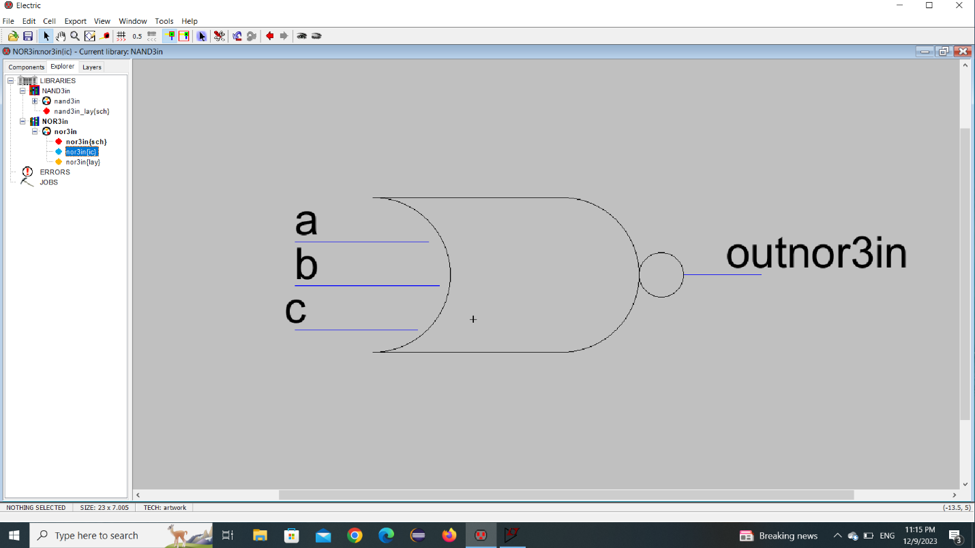

NOR Sizing:

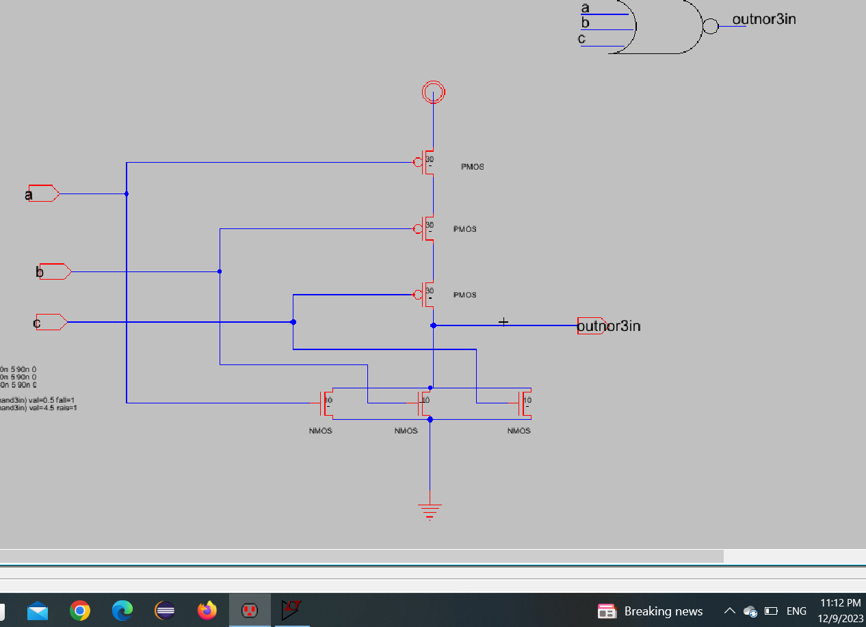

No error Befor run:

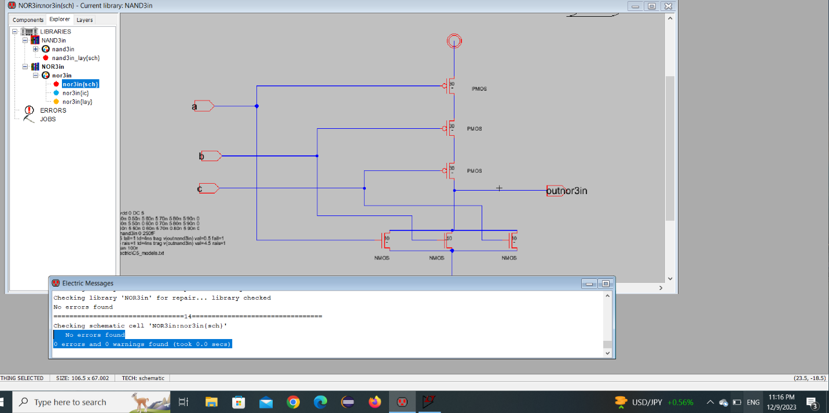

Nor Layout:

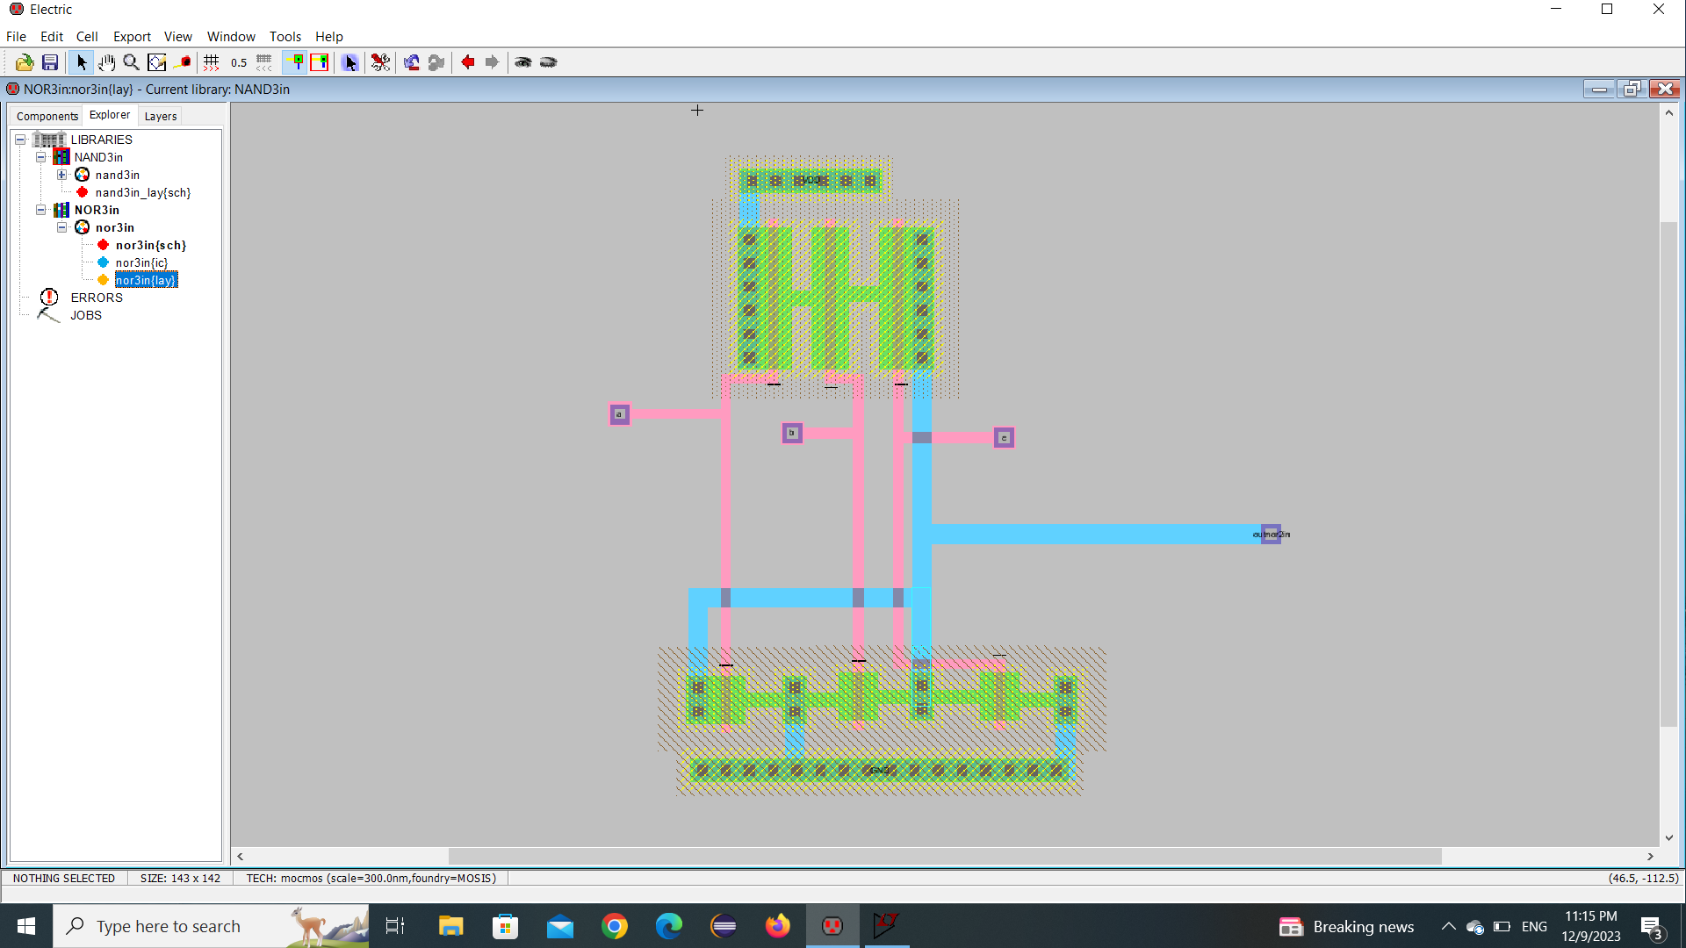

Nor elabrate with waveform:

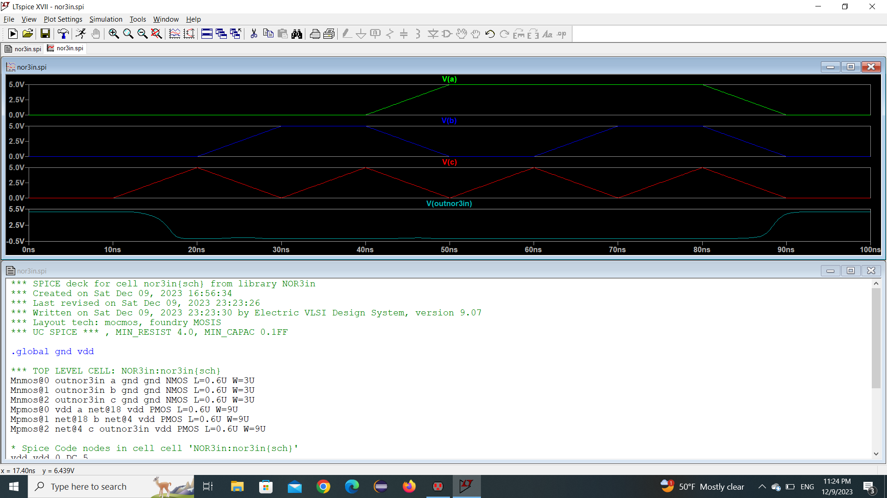

Final result with tr and tf :

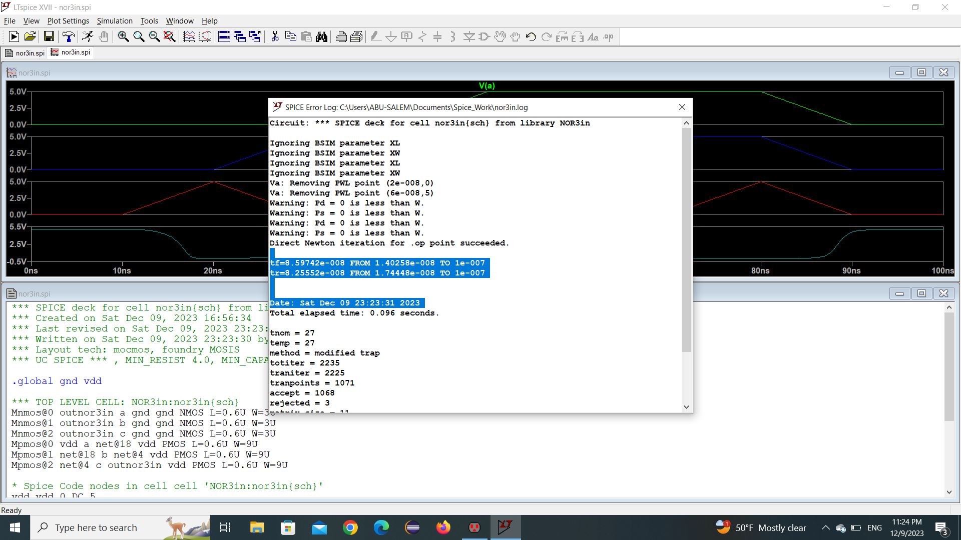

**4.One bit Pass Gate**

One bit pass gate in schematic

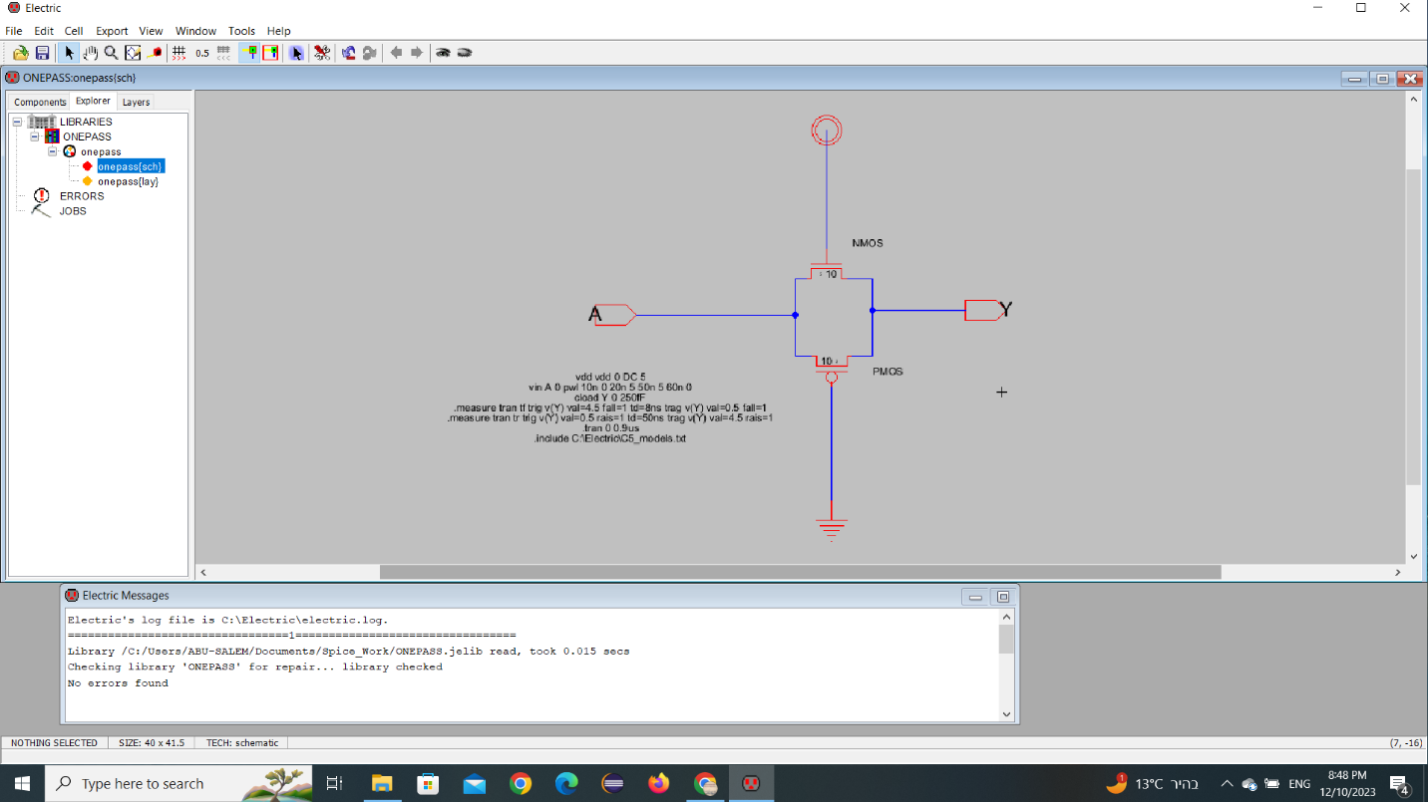

One bit pass gate Layout:

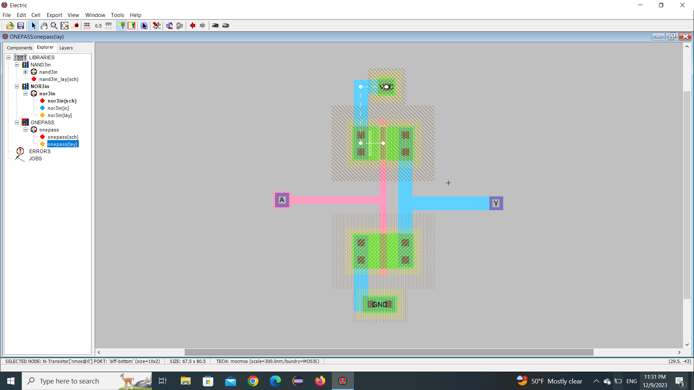

One bit pass gate elabrate with waveform:

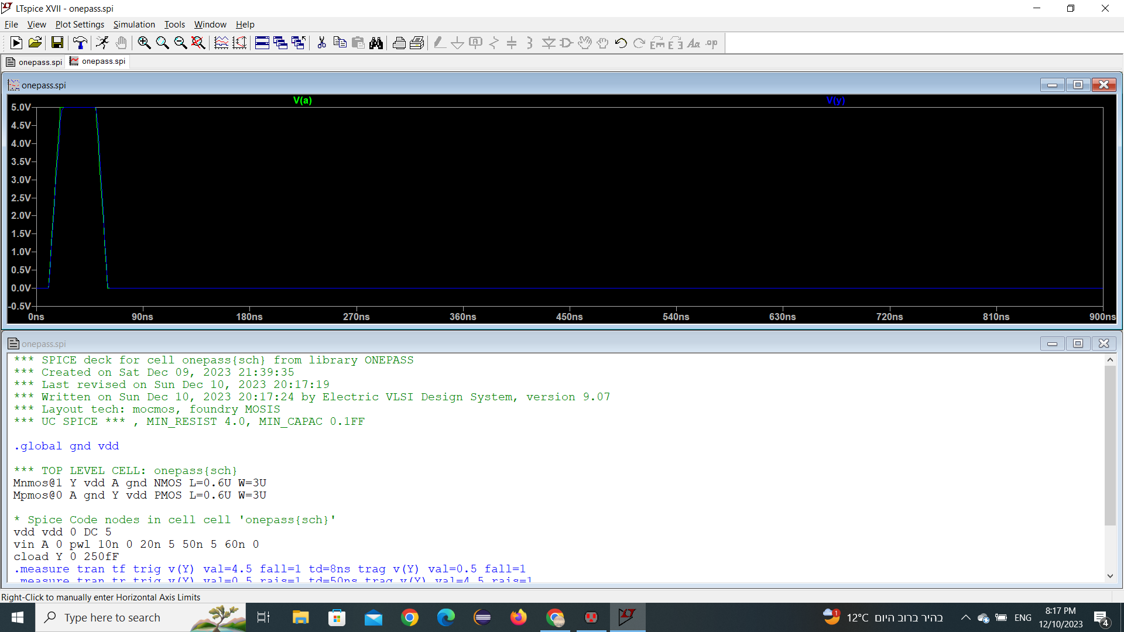

Final result with tr and tf :

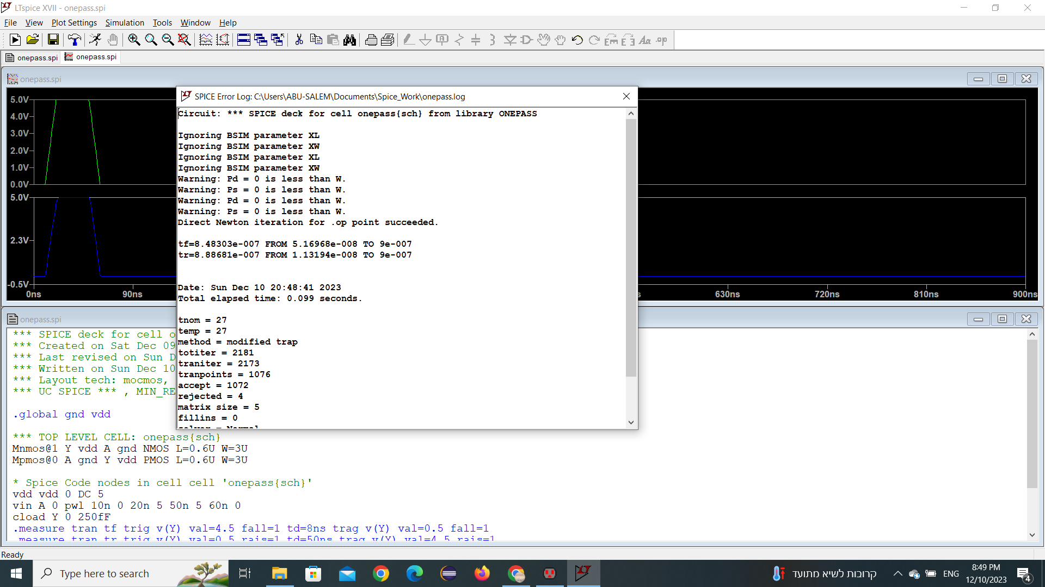

I put size of NMOS and PMOS are equals (Inverter)

Wn=10 , Wp=10

|  |  |  |  |  |
| --- | --- | --- | --- | --- |
|  | Inverter | 3input NAND gate | 3input NOR gate | One bit pass gate |
| Size | Wn+Wp | 90Wn+30Wp | 30Wn+90Wp | Wn+Wp |

The tf and tr are equals at all signals in my designe.

Thancks for reading

Mohammad Salem - 1200651